Countable and Uncountable Nouns
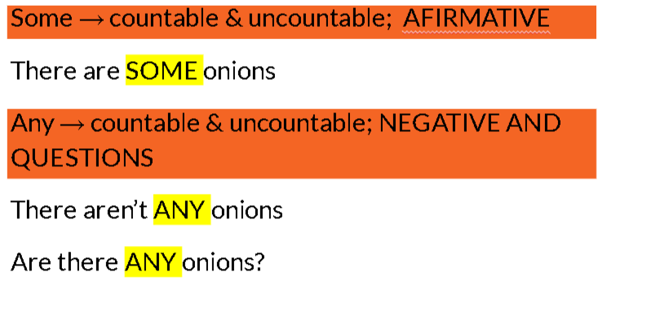
Activity: https://es.liveworksheets.com/worksheets/en/English_as_a_Second_Language_(ESL)/Countable_and_uncountable_nouns/How_much$_or_How_many$_bf1398939ge
https://es.liveworksheets.com/worksheets/en/English_as_a_Second_Language_(ESL)/Countable_and_uncountable_nouns/A,an,some,any,a_lot_of,much,many,how_much,_how_many_ef1891522gx
Prepositions of Place
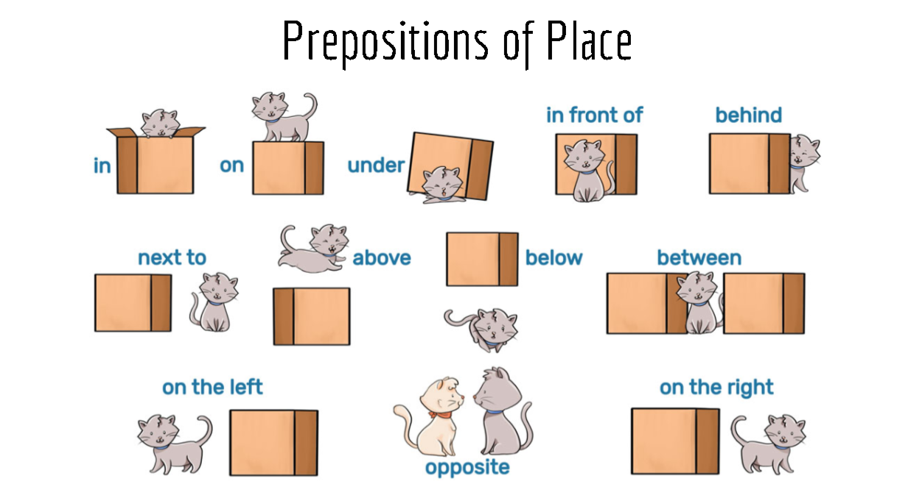

Giving Directions
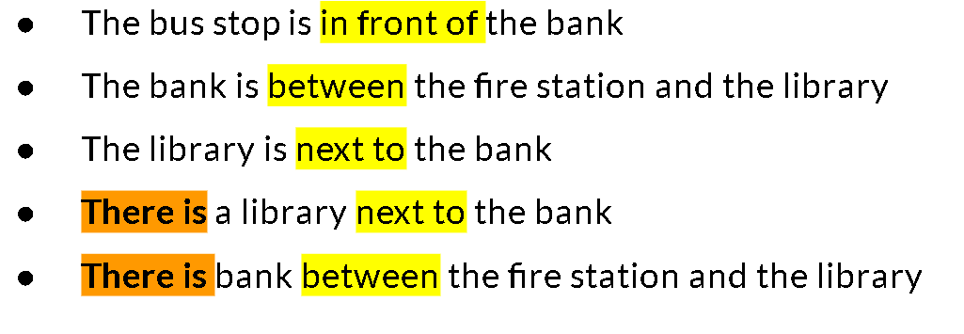
Activity
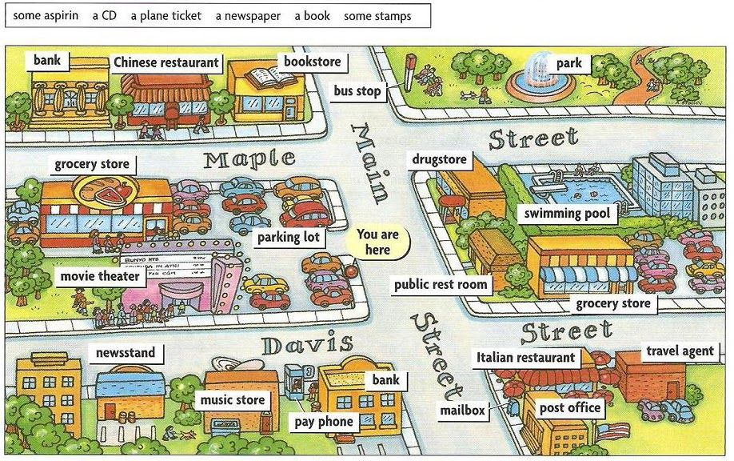

“I have got”
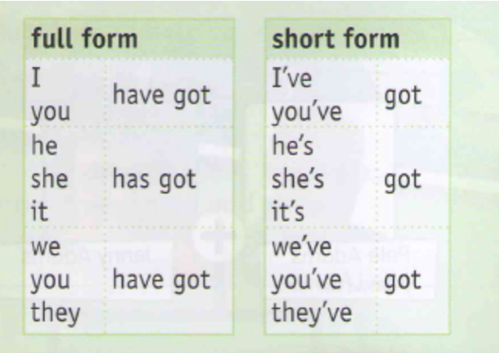
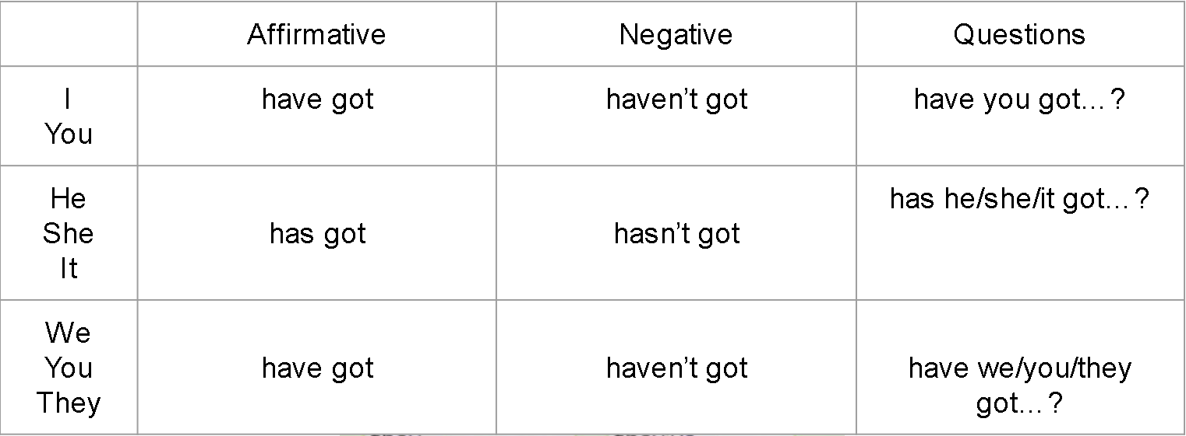

Activity: https://es.liveworksheets.com/worksheets/en/English_as_a_Second_Language_(ESL)/Have_got_-_Has_got/To_have_bo43667cn
https://es.liveworksheets.com/worksheets/en/English_as_a_Second_Language_(ESL)/Have_got_-_Has_got/Have-has_got_(affirmative_and_negative)_bi1257432ta
The Present Simple
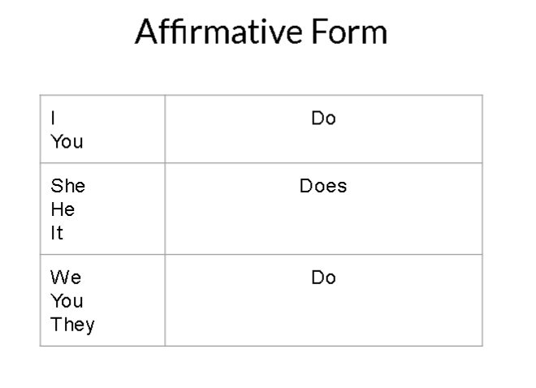
Activity: https://es.liveworksheets.com/worksheets/en/English_as_a_Second_Language_(ESL)/Present_Simple/Simple_Present_-_Affirmative_pg130944do
https://es.liveworksheets.com/worksheets/en/English_as_a_Second_Language_(ESL)/Present_simple_affirmative/Present_simple_affirmative_mh64249ut

